After the successful launch of the panel, go to the **“Builder” tab**:

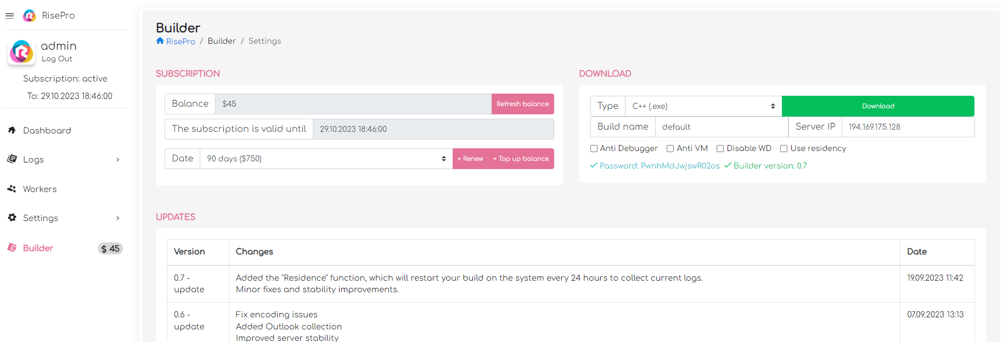

In the upper left corner, we have the status of the subscription, if it is not active, then replenish the balance and renew the subscription by selecting the required period and clicking the “Renew” button.

Next, we get Build:

It is possible to prescribe a Build name, creating workers with it and sorting the logs in the future.

It is possible to install Anti Debugger, Anti VM and disable Windows Defender when starting RisePro.

Use residency is a function that activates the launch of the stealer in the victim’s system every 24 hours to obtain up-to-date data.

After setting the necessary settings, click Download, the archive will be downloaded, the password for which is specified in the panel (under the build settings).

**“Settings” tab:**

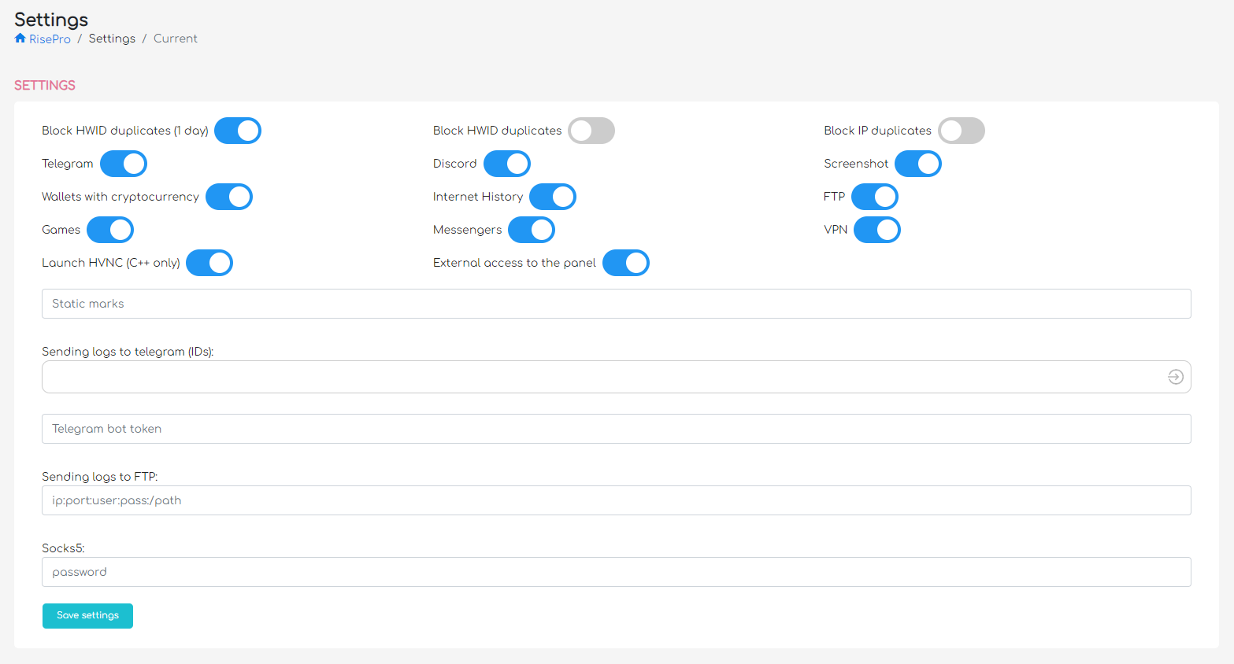

Block HWID duplicates (1 day) – blocks the loading of logs whose HWID has already been encountered during the last day.

Block HWID duplicates - blocks the loading of logs whose HWID has already been met.

Block IP duplicates - blocks the download of logs whose IP has already been met.

Telegram - Enables Tegeram data collection (tdata).

Discord - Enables the collection of Discord tokens.

Screenshot - enables the collection of screenshots at the time of RisePro startup.

Wallets with cryptocurrency - includes the collection of crypto wallets.

Current list:

Extensions:

MetaMask, Jaxx Liberty Extension, iWallet, BitAppWallet, SaturnWallet, GuildWallet, MewCx, Wombat, CloverWallet, NeoLine, RoninWallet, LiqualityWallet, EQUALWallet, Guarda, Coinbase, MathWallet, NiftyWallet, Yoroi, BinanceChainWallet, TronLink, Phantom, Oxygen, PaliWallet, Bolt X, ForboleX, XDEFI Wallet, Maiar DeFi Wallet, KardiaChain, Terra, Harmony, Name, Exodus, MathWallet, Keplr, Sollet, AuroWallet, PolymeshWallet, ICONex, EVER Wallet, Rabby, BraveWallet, WavesKeeper, Solflare, CyanoWallet, KHC, TezBox, Temple, Goby, Braavos wallet, Eth and Polk Web3 Wallet, OKX Wallet, Sender Wallet, Hashpack, Eternl, GeroWallet, Pontem Aptos Wallet, Petra Aptos Wallet, Opera Wallet, EMartian Aptos Wallet, Finnie, Leap Terra Wallet, Trust Wallet

Cold Wallets:

Atomic, Electrum, Exodus, Electrum LTC, Monero, Jaxx Libertry, Jaxx, Coimoni, Armory, Wasabi, Bither, ElectronCash, Binance, Guarda, MultiDoge, Bitroin, Dogecoin, Anoncoin, BBQCoin, DashCore, FlorinCoin, Franco, Freicoin, GoldCoin, IOCoin, Infinitecoin, Ixcoin, Megacoin, Mincoin, Namecoin, Primecoin, Terracoin, YACoin, Zcash, devcoin, digitalcoin, Litecoin, Reddcoin, Daedalus Mainnet, Ledger Live

Internet History - includes the collection of recent visits to web browser pages

FTP – enables collection of FTP program configs

Games – includes a collection of popular games and game launchers

Messengers – includes collection of messenger configs

VPN – includes collection of configs of popular VPN programs

Launch HVNC - launch and add HVNC to startup after loading the log

External access to the panel – enables external access to the panel (when disabled, access only via http:/localhost:8081/)

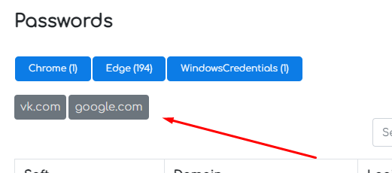Static marks: filling - listing domains separated by commas "vk.com,google.com", used to sort passwords in a modal window:

Sending logs to telegram (IDs): - sending logs to telegrams by chat ID,

For this function to work, you need to create a bot and specify the token in the "Telegram bot token" field

Next, add chat IDs by writing off the ID and clicking on the arrow on the right of the field





After that, we save and write /start to the bot with the ID that was added to the list.

Sending logs to FTP – sending logs to a specified FTP account

Socks5 – set a password for the Socks5 proxy (works with HVNC). Login – rise.

**«Marks» tab:**

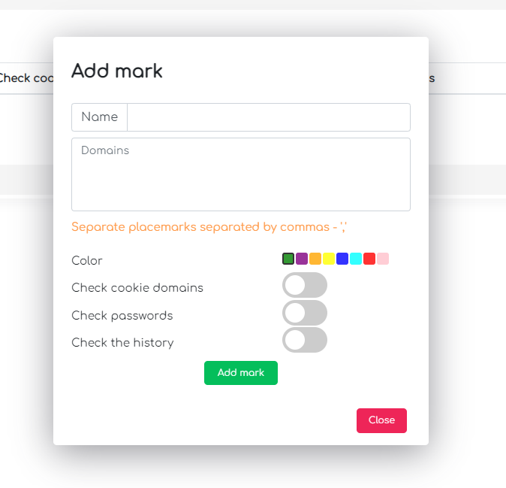

Specify the label name, domains (or url) separated by commas (without spaces), select the color, whether to check the specified domains in cookies, passwords and history.

Tags are needed for convenient sorting of logs and creating workers. Also, the found tags will be reflected in the sent telegram log. Usage example - indicates the domains of crypto exchanges, and then you can easily display all the logs in the panel with crypto exchanges.

**«Grabber» tab:**

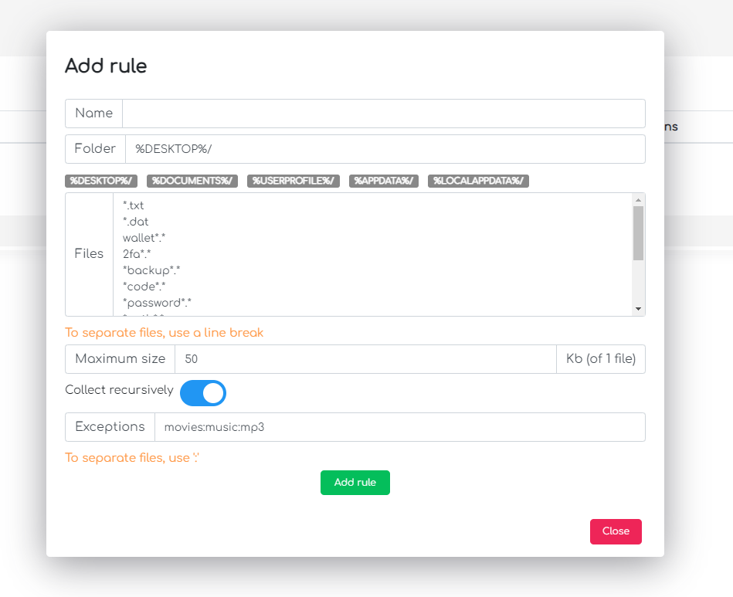

Collection of files according to the specified rules.

The folder can also be specified in the format "С:\\Users\\"

Files are specified on a new line, where * means any characters

Collect recursively - recursively iterate through all subfolders

Exceptions are specified with ":" and exclude folders and files if found in their name

**«Loader» tab:**

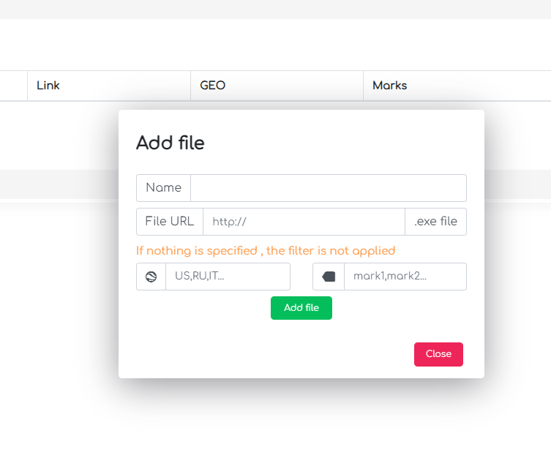

Used to download and open files when launching RisePro at the specified URL.

You can also specify the GEO for which this Loader will work.

It is also possible to specify a list of labels (names) separated by commas, on which this Loader will work.

**«Workers» tab:**

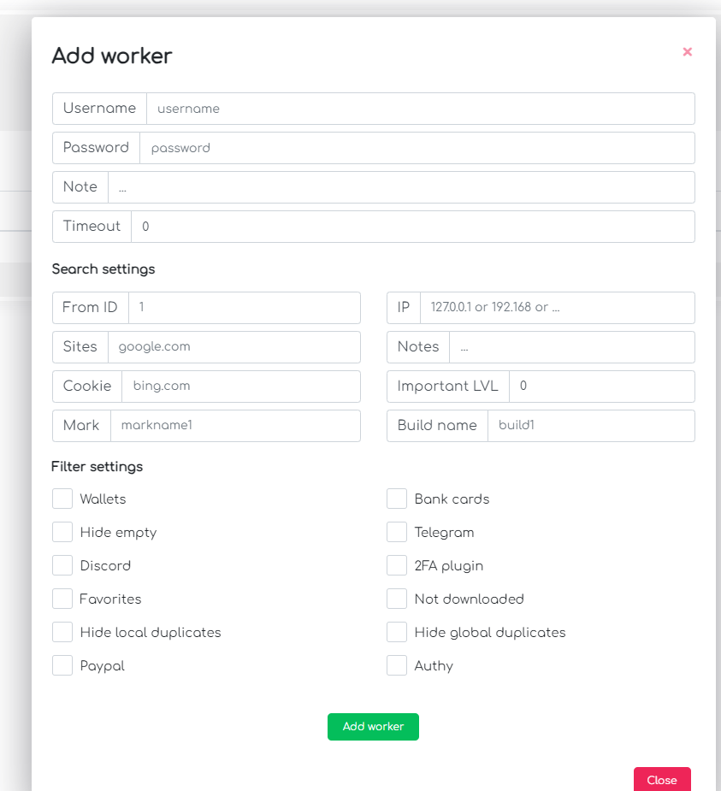

Used to create a worker account.

Timeout - time in seconds after which the log will appear in the panel for the worker.

All the filters that you set the worker will not be able to change, if the filters are not set, the worker can change the filters at will.